BIT 4107 – Mobile Application Development
ENHANCED PROFESSIONAL STUDENT LOGBOOK
STUDENT NAME: FAITH WANJA
ADMISSION NUMBER: BIT 2024/74102
SCHOOL/FACULTY: SCHOOL OF COMPUTING AND INFORMATICS
PROGRAMME: INFORMATION TECHNOLOGY
ACADEMIC YEAR: YEAR 3
SEMESTER: SEMESTER 2
LECTURER: MR NYORO
PHONE NUMBER: 0746505876

Table of Contents
BIT 4107 – Mobile Application Development 1
Week 1: Introduction to Mobile Application Development 2
1.1 Practical Activities Undertaken 2
1.2 Tools/Software Used 3
1.3 Personal Reflection 3
Week 2: Mobile Development Environment 3
2.1 SDK setup 3
2.2 Flutter project app set up 4
2.3 Emulator running 4
2.4 Creating First app 5
2.5 Changing font size, app title and background color 5
2.6 Programming languages practice 5
2.7 Personal Reflection 6
Week 3: User Interface Design 6
3.1Wireframes and mockups of student registration app 6
3.2 Wireframe to code implementation 8
3.3 Wireframes and mockups of e-commerce choice app 8
3.4 Wireframe to code implementation 9
3.5 Personal reflection 9

Week 1: Introduction to Mobile Application Development
1.1 Practical Activities Undertaken
Learning about various Mobile app development tools.
Installing the tools.

1.2 Tools/Software Used
Android studio

VS code
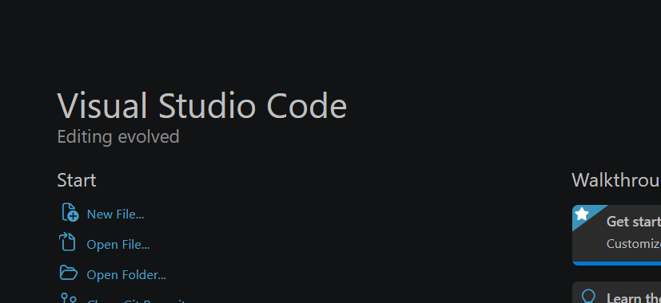

1.3 Personal Reflection
Installation of environments to work on.

Week 2: Mobile Development Environment

2.1 SDK setup
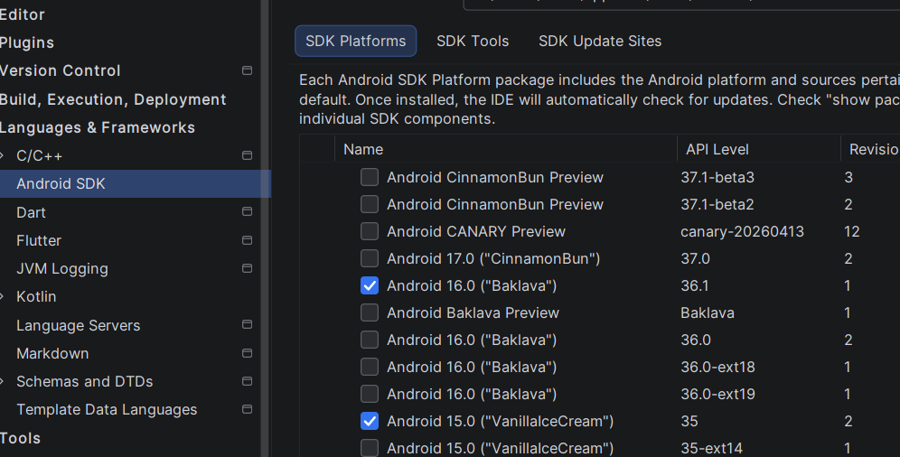

2.2 Flutter project app set up
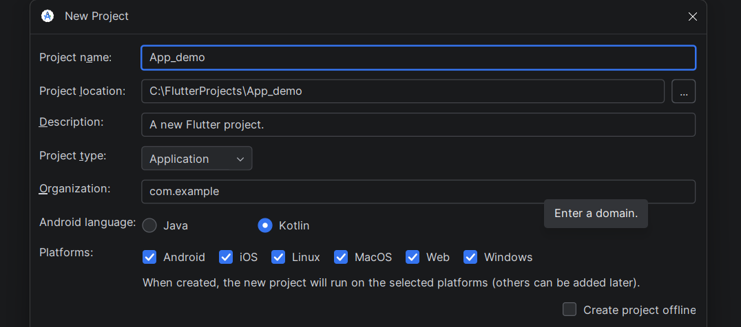

2.3 Emulator running
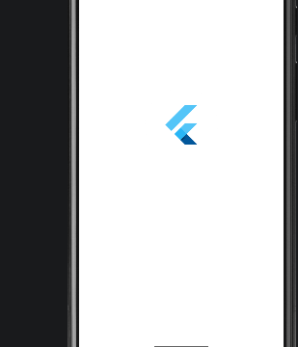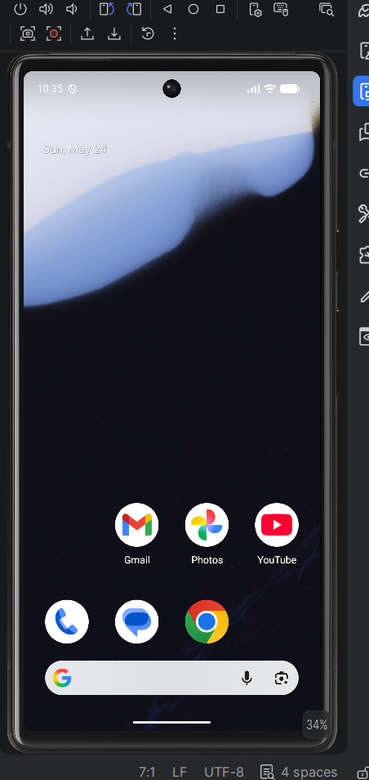

2.4 Creating First app
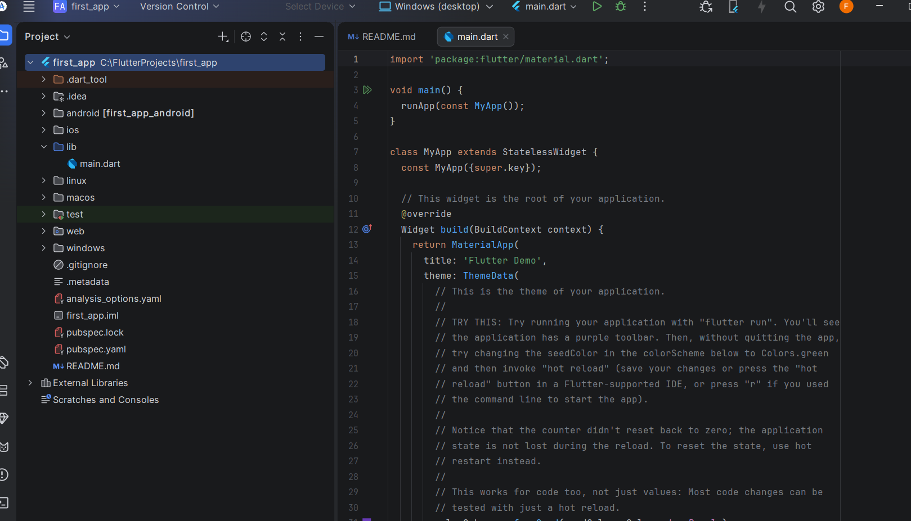

2.5 Changing font size, app title and background color
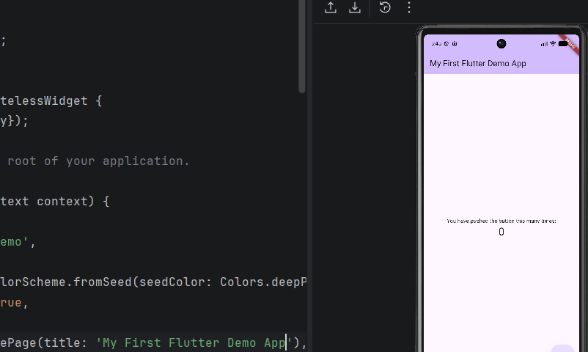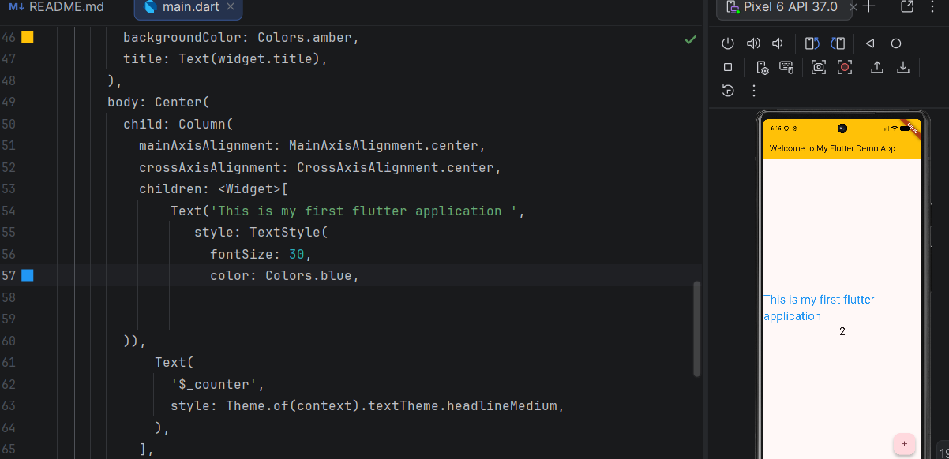

2.6 Programming languages practice
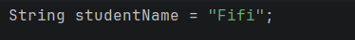
Classes practice:
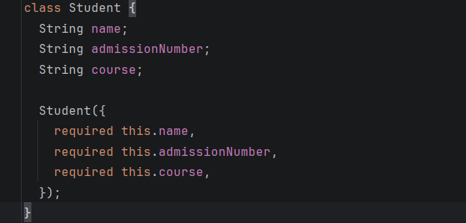

2.7 Personal Reflection
I learned how to set up Flutter development environment, create a new project and run applications. I gained practical experience in Flutter development by creating user interfaces, implementing navigation and applying programming concepts.

Week 3: User Interface Design

3.1Wireframes and mockups of student registration app
Designed application wireframes using Figma. Created login, registration and dashboard screen prototypes of the student management App.
a) Wireframe of a login screen:
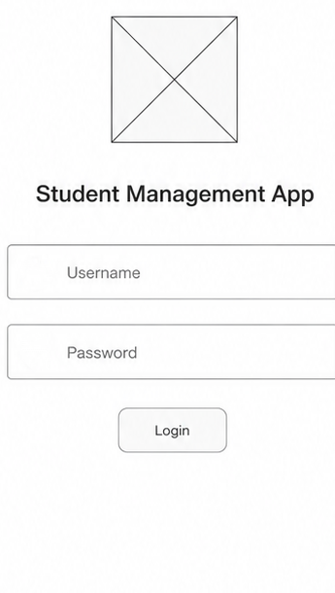

b) Wireframe of a registration screen
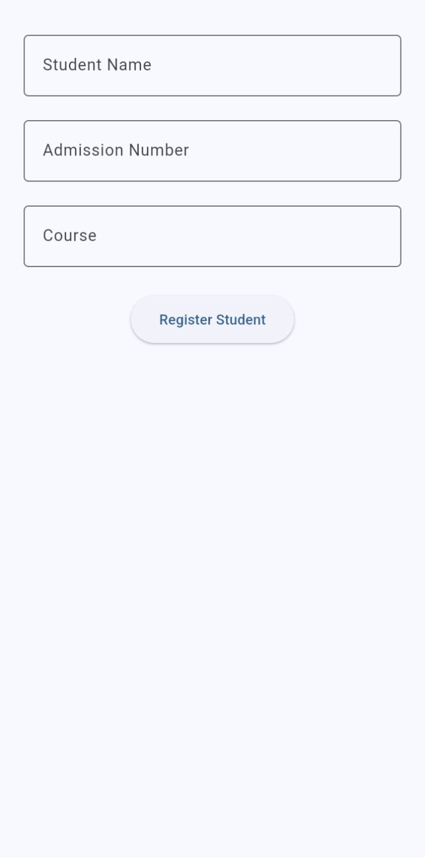
c) Students’ dashboard
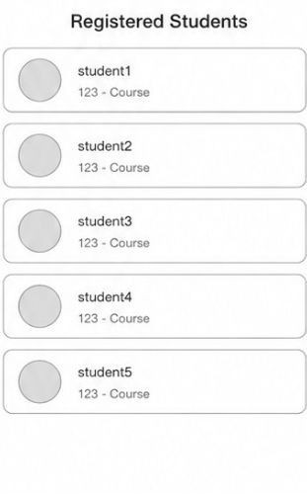

3.2 Wireframe to code implementation
Fig 1: 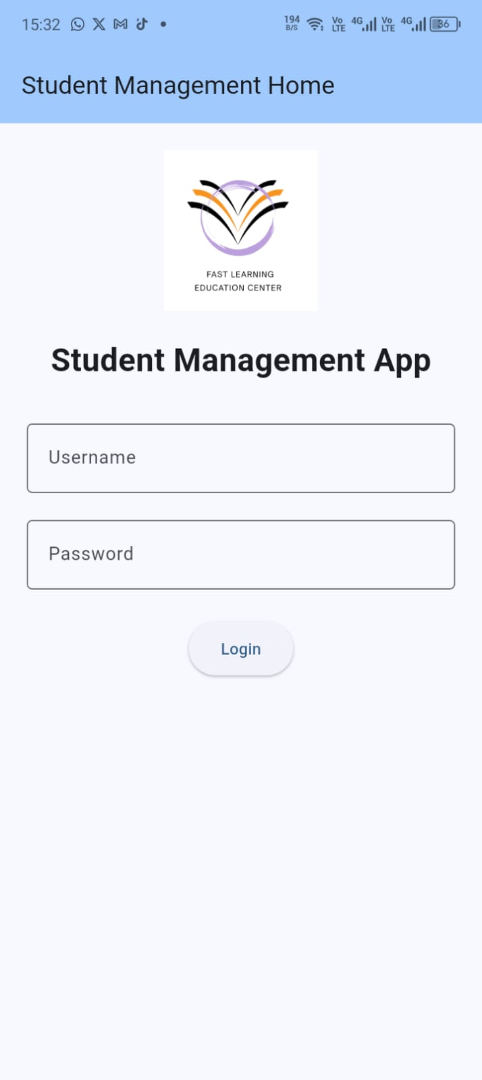 Fig 2: 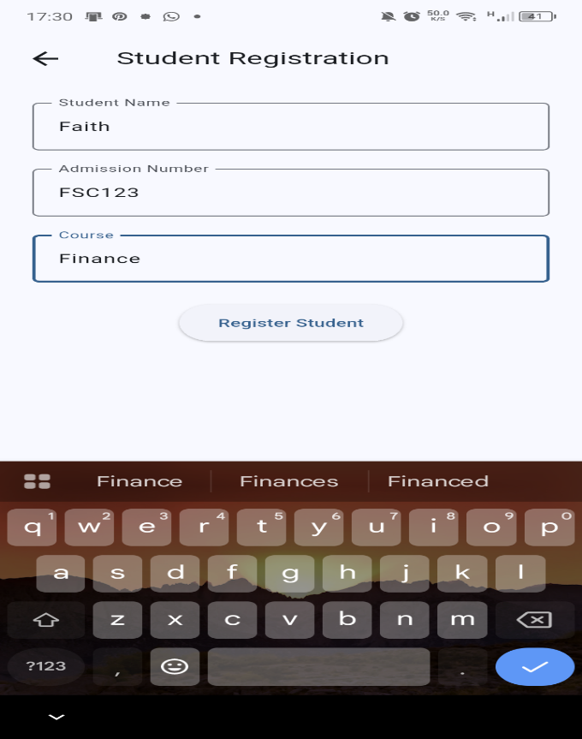 Fig3: 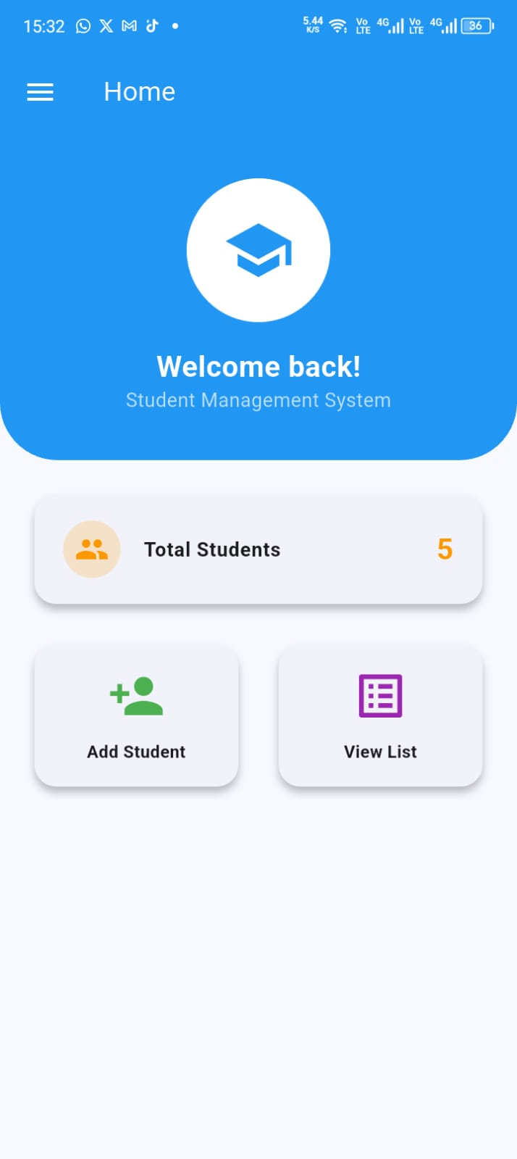
Fig 4: 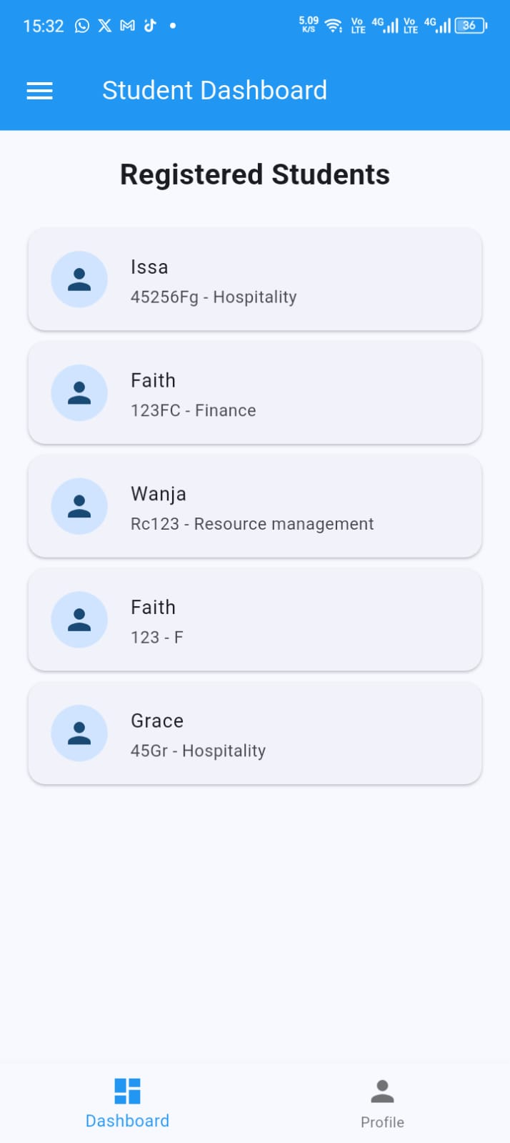 Fig 5: 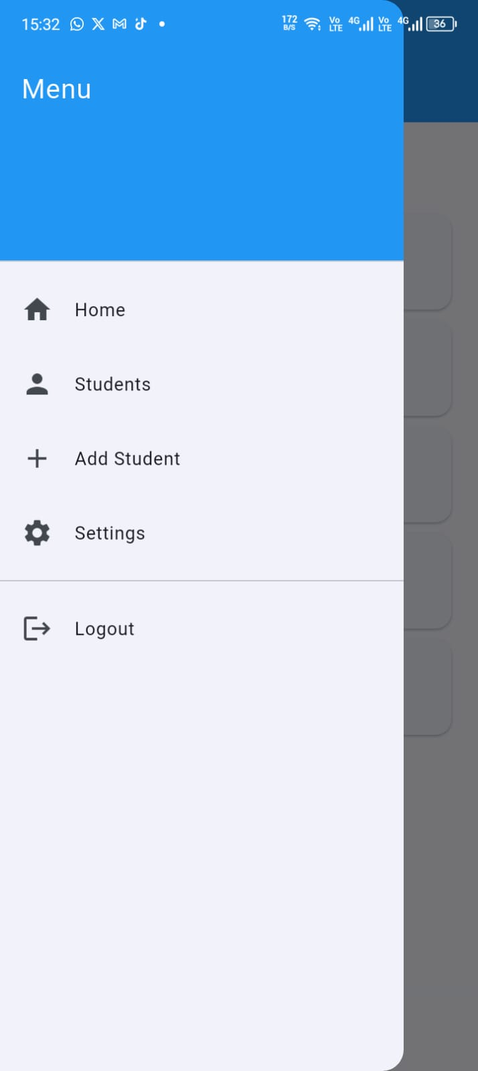

3.3 Wireframes and mockups of e-commerce choice app
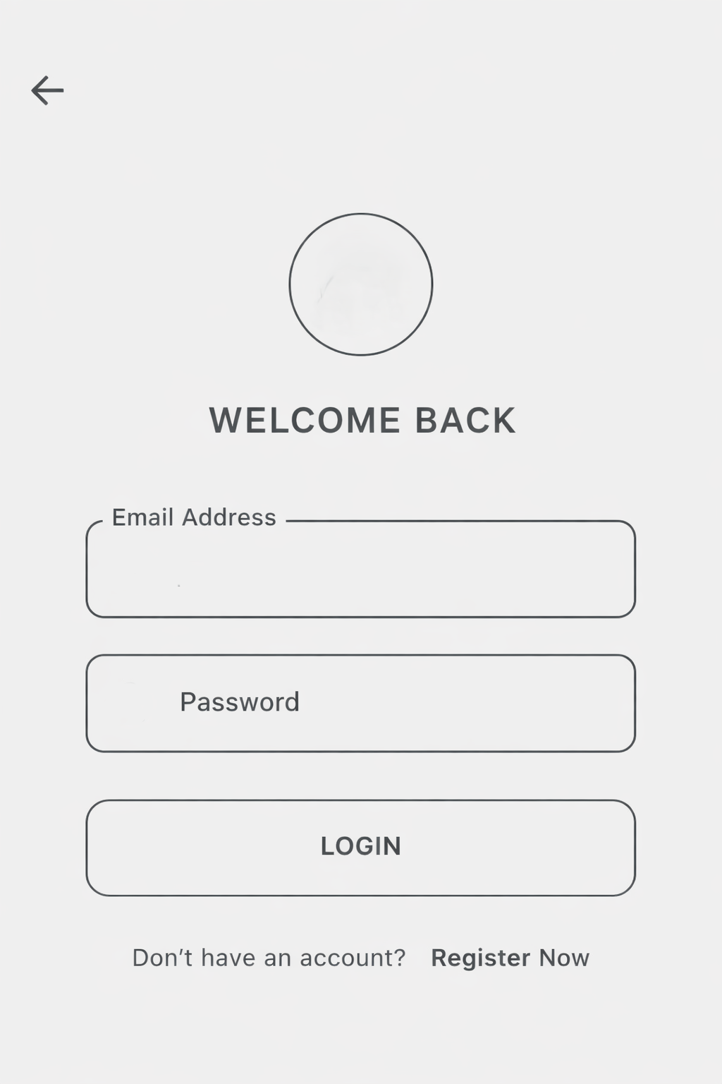 a) Login screen 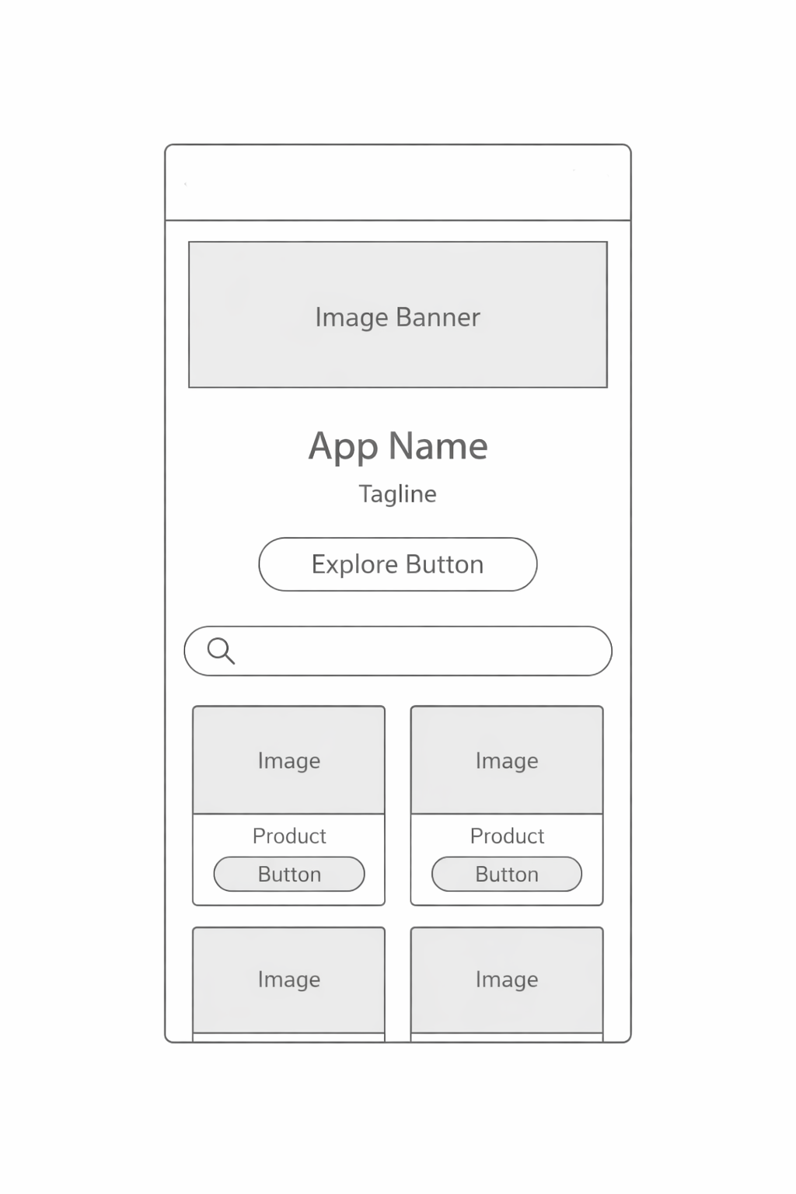 b) Products screen

3.4 Wireframe to code implementation
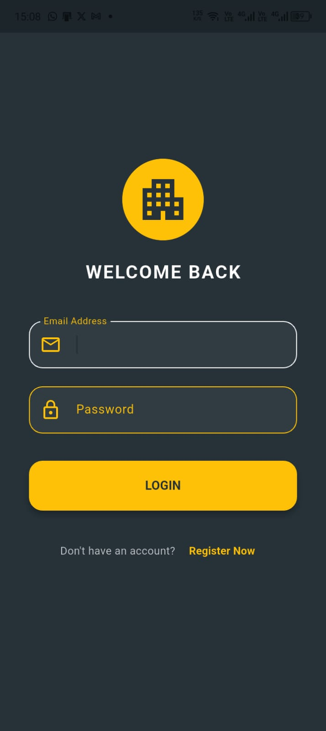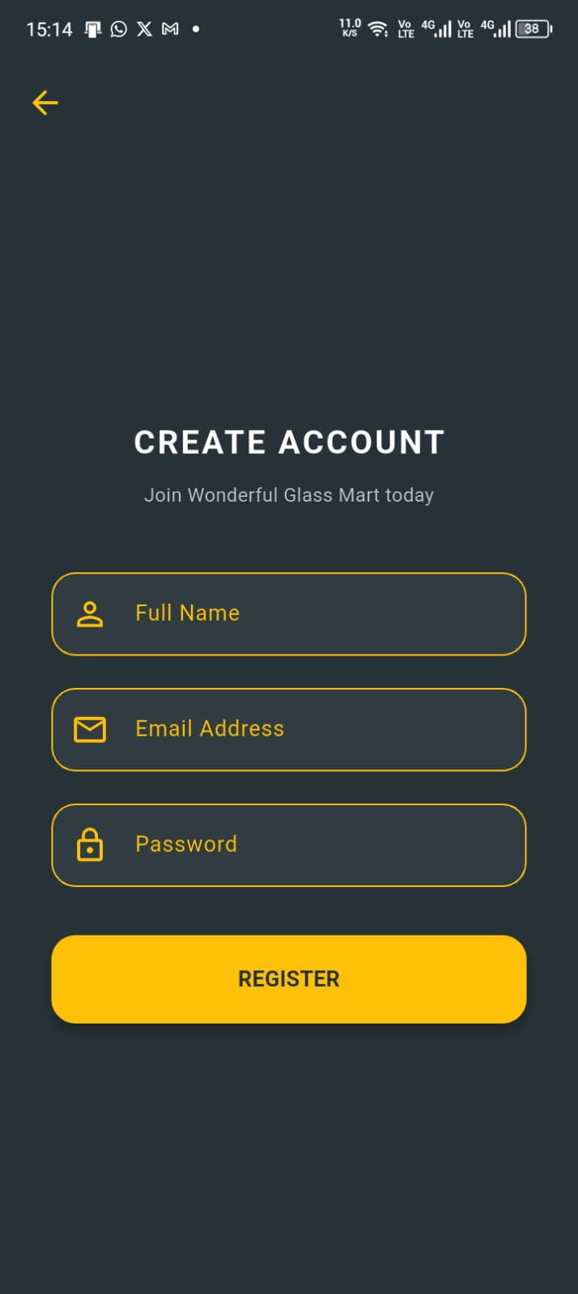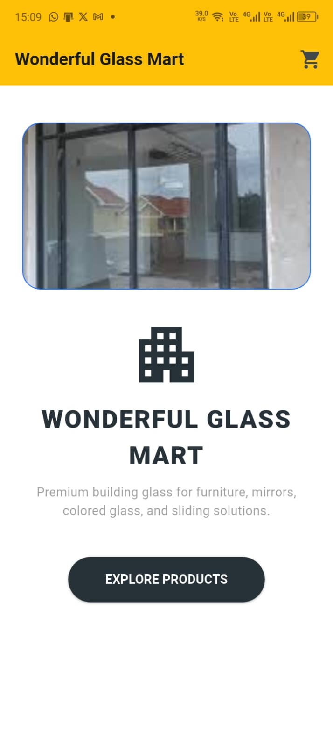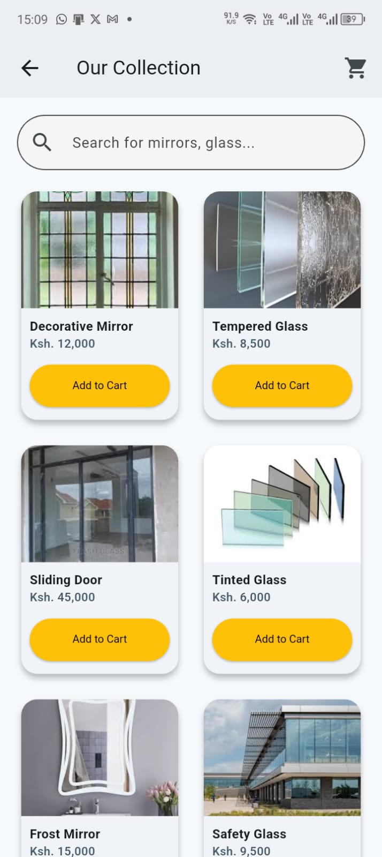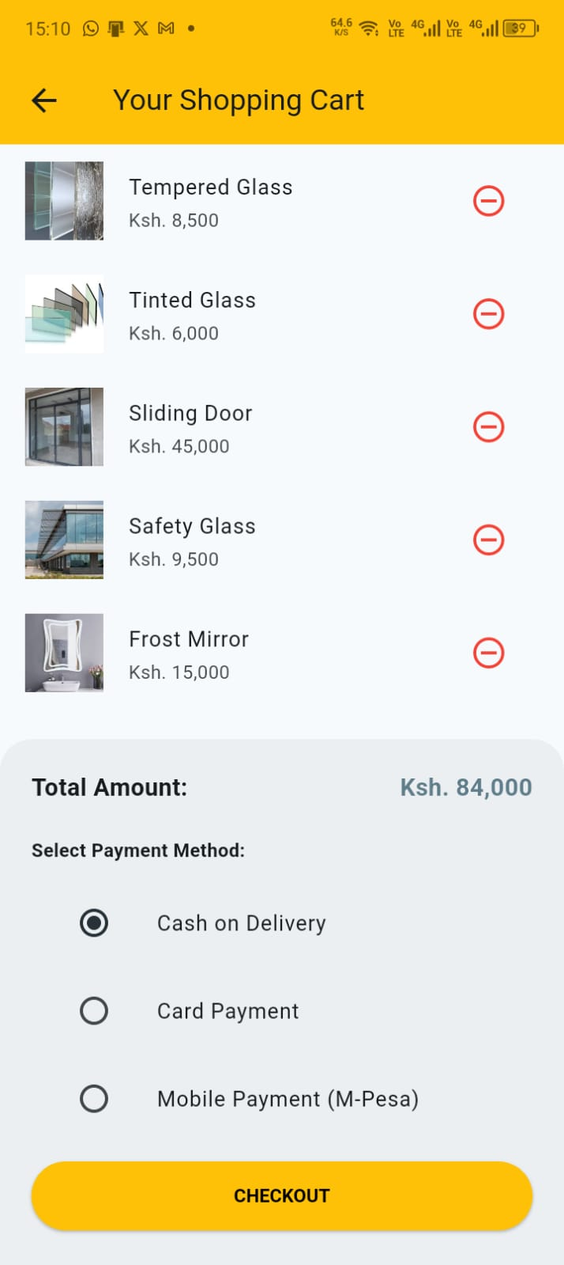

3.5 Personal reflection
The screen prototypes in Figma were implemented in Flutter using widgets such as TextField, ElevatedButton, Image, Column and scaffold. The implemented screen closely followed the layout and structure defined in wireframes.
This practical enhanced my skills in mobile application development by combining user interface design, Flutter Programming and navigation to build functional apps.

